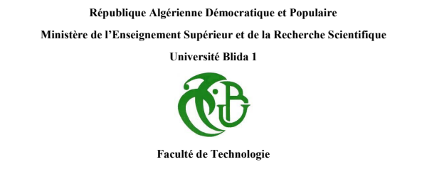
Département d’automatique

Spécialité automatique

Smart Assistive Device for the Visually Impaired

presented by:
MELEK HASNAA
Framed by:
Mr. Kazed

2022/2023

Acknowledgements
I am reminded of the profound saying, "And whoever is grateful is grateful for [the benefit of] himself. And whoever denies [His favor] – then indeed, Allah is Free of need and Praiseworthy" (Quran 31:12). Therefore, I am grateful to Allah for the opportunity to express my thanks and recognize His infinite blessings
I would like to express my deepest gratitude to Allah, the Most Merciful and the Most Gracious, for His blessings, guidance, and unwavering support throughout the completion of this project
I am deeply thankful to my project supervisor Mr. Kazed, for their continuous support. Their invaluable insights and feedback have significantly contributed to the success of this project.
Furthermore, I would like to thank my family for their constant encouragement, love, and understanding throughout this project. Their unwavering support and belief in my abilities have been a source of motivation and strength.

Dedications
First and foremost, I dedicate this work to the man and woman of my life to my parents a source of inspiration MELEK ABDELHAK first one who believed on me since day one and supported me during my 20 years the man who taught me how to fight and not quit, TACHANTCHANE DJOUIDA a creation that comes once only the one who was there in my highest and lowest, I’m so grateful I get my strength from the strongest women ever a mom a sister and even a friend mostly actually
Your love, guidance, and constant encouragement have shaped me into the person I am today.
I dedicate this work to the source of patience a miracle in my life grandma I’m convinced it’s a world loss this is for you grandma
I also dedicate this work to my siblings Your presence in my life has brought joy, laughter, and companionship, and I am grateful for the bond we share
To my friend who was always there for me to the best listener in the world
And to my lovers and haters because you guys each day add something to me
Summary
Abstract ……………………………………………………..page1
Introduction …………………………………………………page2
Mechanical part ……………………………………………..page3
Electronic part ……………………………….…..….. page4-5-6-7
Programming part………………………….……page8-9-10-11-12
Conclusion …………………………………………...….page13-14
Annex ……………………………………………….…..page15-16
Bibliography…………………………………………………page17
Photo of the realization ………………………………………page3
Wiring circuit…………………………………………………page7
Photo of the circuit …………………………………………..page7
organizational chart…………………………………………..page8
Arduino uno R3 datasheet……………………………………page16
MPU6050 datasheet …………………………………………page16
GPS neo6m datasheet ………………………………………..page17
HC-05 Bluetooth datasheet…………………………………...page17
Buzzer datasheet………………………………………………page17
Ultrasonic datasheet…………………………………………..page17

Abstract
This project focuses on developing a system to assist blind individuals by detecting falls and obstacles. It incorporates an ultrasonic sensor, a buzzer for obstacle detection an MPU6050 accelerometer for fall detection. additionally, it includes a GPS module and HC-05 Bluetooth module to send the location messages to the user’s family in case the user fall or press the pushbutton
Key words: Blind individuals Fall, detection, Obstacle detection, Ultrasonic sensor, Buzzer, MPU6050 accelerometer, GPS module, HC-05 Bluetooth module
Résumé :
Ce projet se concentre sur le développement d'un système pour aider les personnes aveugles en détectant les chutes et les obstacles. Il intègre un capteur ultrasonique et un buzzer pour la détection des obstacles ainsi qu'un accéléromètre MPU6050 pour la détection des chutes. De plus, il comprend un module GPS et un module Bluetooth HC-05 pour envoyer des messages de localisation à la famille de l'utilisateur en cas de chute ou d'appui sur le bouton poussoir.
Mots-clés : Personnes aveugles, Détection de chute, Détection d'obstacles, Capteur ultrasonique
Buzzer, Accéléromètre MPU6050, Module GPS, Module Bluetooth HC-05
التلخيص
يركز هذا المشروع على تطوير نظام لمساعدة الأفراد المكفوفين عن طريق اكتشاف السقوط والعقبات. وهو يشتمل على جهاز استشعار بالموجات فوق الصوتية و الطنان لكشف العوائق ومقياس تسارع MPU6050 لكشف السقوط. بالإضافة إلى ذلك، فإنه يتضمن وحدة GPS ووحدة بلوتوث HC-05 لإرسال رسائل الموقع إلى عائلة المستخدم في حالة سقوط المستخدم أو ضغطه على الزر
كلمات المفتاحية : سقوط الأفراد المكفوفين، الكشف،كشف العوائق، جهاز استشعار فوق صوتي، طنان، مقياس تسارع MPU6050، وحدة GPS، HC-05 وحدة بلوتوث
Page-1-

Introduction
The constant evolution of technology has given rise to many revolutions in various scientific fields, especially in the field of automation, which has completely changed our way of living by facilitating daily tasks and solving problems. Progress in this field has not only simplified and popularized complexity but also empowered individuals to create and innovate with minimal costs. One significant advancement is the development of microcontrollers and various development boards such as Arduino. Based on the principle of this accessible simplicity, using Arduino and its modules, we can create a project concept and work towards solving a common issue, as is the case in this topic: replacing a simple cane for visually impaired individuals with an enhanced and secure cane to improve their mobility
The goal of this project is to develop an innovative system that assists blind individuals by detecting falls and obstacles in their surroundings. The project aims to enhance their safety, provide immediate alerts, and enable communication with their family members or caregivers in case of emergencies.

Areas of Application:
Assistive Technology: The project finds applications in the field of assistive technology, helping blind individuals navigate their environment independently and with increased safety.
Healthcare Facilities: The system can be implemented in healthcare facilities, rehabilitation centers, and senior care facilities to improve the well-being and safety of visually impaired patients and retirement homes

The main objective of this project is to develop an advanced and secure cane for visually impaired individuals using Arduino and its modules. The project aims to improve the mobility and safety of visually impaired individuals by incorporating features such as obstacle detection, fall detection, and location tracking. By utilizing ultrasonic sensors, accelerometers, and GPS modules, the cane will be able to detect obstacles in the user's path, detect falls, and send location information to a designated contact in case of emergencies

Page -2-
Mechanical part:
Cane Structure:
The cane should have a sturdy and ergonomic structure to provide stability and support to the user. It should be lightweight and easy to hold
Handle: The handle should be ergonomically designed to provide a comfortable grip. It should be easy to hold and allow for a secure and firm grasp
Length Adjustability: Consider incorporating a mechanism that allows the length of the cane to be adjusted according to the user's height and preferences. This feature ensures that the cane can be properly customized for each individual
Accessories and Attachments: The cane can have attachments or accessories to enhance functionality
Fall Detection Mechanism:
Implement a fall detection mechanism using the MPU sensor's accelerometer readings. Analyze the acceleration data and set specific thresholds to determine if a fall has occurred based on changes in acceleration patterns
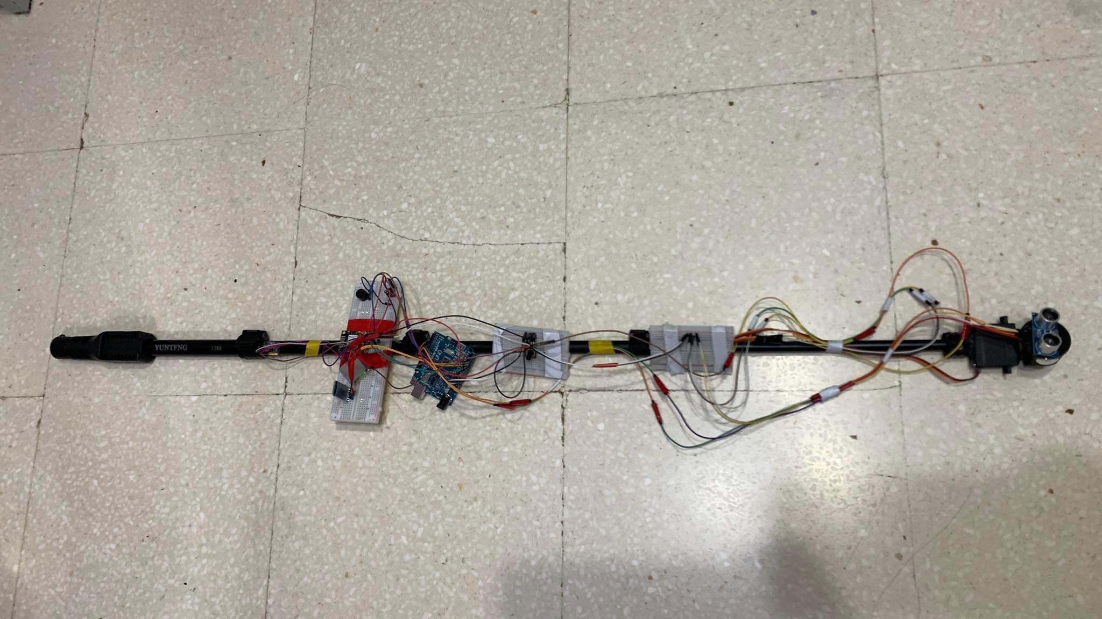
-Photo of the realization-

Page-3-
Electronic part:
Arduino Microcontroller:
Arduino is an open-source electronics platform based on easy-to-use hardware and software. It consists of a programmable microcontroller board and a development environment that allows users to write, upload, and run code to control various electronic components and devices. The Arduino board serves as the main component of the platform, containing a microcontroller (such as the ATmega328P) and input/output pins that can be connected to sensors, actuators, and other electronic modules. It also includes built-in features like analog-to-digital converters (ADCs), digital input/output (I/O) pins, and communication interfaces (e.g., USB, serial, I2C, SPI). The Arduino development environment, often referred to as the Arduino IDE (Integrated Development Environment), is a software tool used to write and upload code to the Arduino board. It provides a simplified programming language based on C/C++ and a user-friendly interface for writing, compiling, and uploading sketches (Arduino programs) to the board
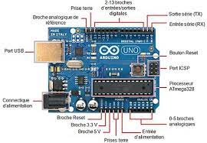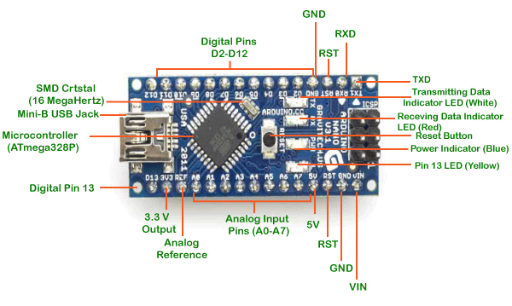
Ultrasonic Sensor:
Ultrasonic refers to high-frequency sound waves or vibrations above the range of human hearing. They are used in various applications such as medical imaging, industrial testing, cleaning, and object detection. Ultrasonic sensors emit short pulses of ultrasonic waves and measure the time it takes for them to bounce back, providing information about distance and object presence. Their ability to propagate through different materials makes them versatile and non-invasive for precise measurements and detection

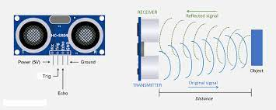
Buzzer (Piezoelectric Effect) :
A piezoelectric speaker (also known as a piezo bender due to its mode of operation and sometimes familiarly called a "piezo", buzzer, crystal speaker, or beep speaker) is a speaker that utilizes the piezoelectric effect to generate sound. The initial mechanical movement is created by applying voltage to a piezoelectric material, and this movement is typically converted into audible sound using diaphragms and resonators
page-4-
connected to TTL outputs, although more complex drivers can provide higher sound intensity. Generally, they perform well in the range of 1 to 5 kHz and up to 100 kHz in ultrasonic applications
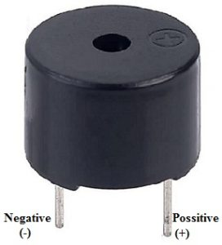
The MPU6050 accelerometer :
a highly advanced sensor module that combines a three-axis accelerometer and a three-axis gyroscope into a single chip. It accurately measures linear acceleration along the X, Y, and Z axes with a range of ±2g to ±16g, and detects angular velocities with a range of ±250°/s to ±2000°/s. It communicates with microcontrollers using the I2C interface and is widely used in robotics, virtual reality, and motion tracking applications. The MPU6050 offers precise motion sensing and control in a compact and efficient package
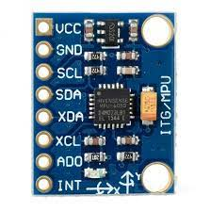
GPS module :
a device that receives signals from multiple satellites to determine precise geographic coordinates. It utilizes the Global Positioning System (GPS) to calculate location information, including latitude, longitude, and altitude. By analyzing the time delay between transmitted and received signals, the module can calculate distances and triangulate the exact location. GPS modules provide high-accuracy real-time positioning, typically within a few meters, and are commonly used in navigation, vehicle tracking, and outdoor applications. They communicate with other devices through serial interfaces and require an external power supply and an active antenna for optimal performance.
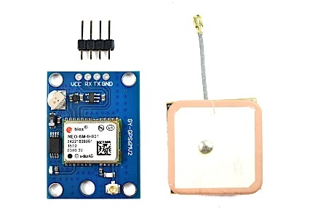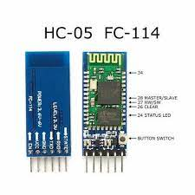page-5-
The HC-05 Bluetooth module:
enables wireless data transmission between devices within a range of 10 meters. It supports baud rates from 1.2 to 921.6 kbps and can function as a master or slave device. Widely used for wireless data transfer and remote-control applications, the HC-05 module is connected via UART and configured using AT commands.

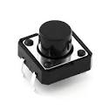
pushbutton:
an electronic switch that completes an electrical circuit when pressed. It allows for manual input or control in electronic systems. Pushbuttons are widely used in user interfaces and control applications. They provide tactile feedback and enable specific actions or events. They are connected to microcontrollers or other devices to detect button presses. Pull-up or pull-down resistors are often used for stable signal detection. Pushbuttons are essential components for manual input and control in electronics
BreadBroad:
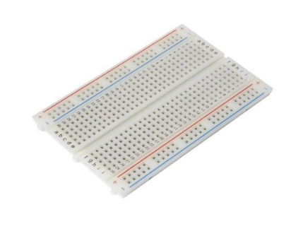
Wires:
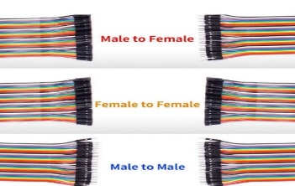

Page-6-
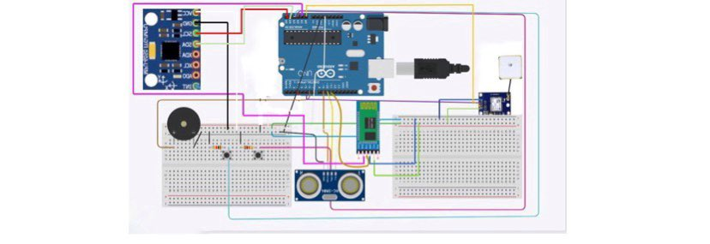
- wiring circuit-
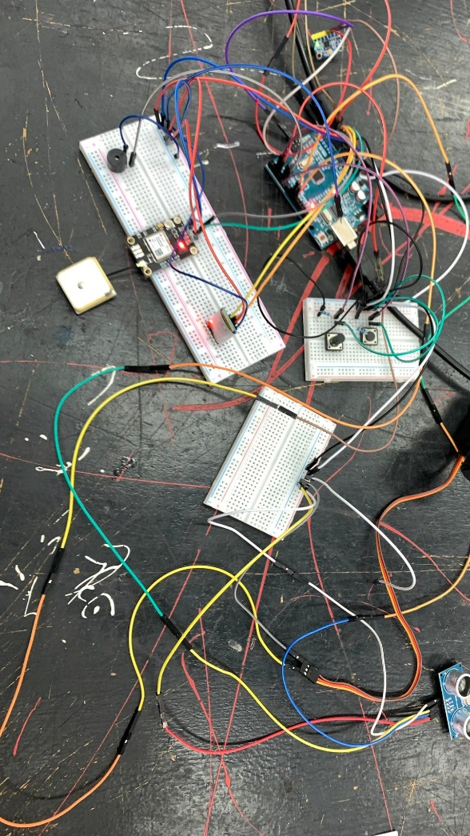
-photo of the circuit-

Page-7-
organizational chart:

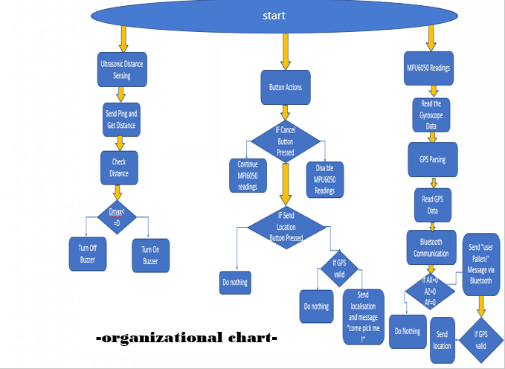
programing part:
The code is made on Arduino IDE 1.8.19 with all the explanations of each line:
#include <NewPing.h> // Library for ultrasonic distance sensing
#include <Servo.h> // Library for servo motor control
#include <Adafruit_MPU6050.h> // Library for MPU6050 accelerometer and gyroscope
#include <Adafruit_Sensor.h> // Library for sensor functionality
#include <Wire.h> // Library for I2C communication
#include <SoftwareSerial.h> // Library for software serial communication
#include <TinyGPS++.h> // Library for GPS parsing
Adafruit_MPU6050 mpu; // Create an instance of the MPU6050 class page-8-

const int trigPin = 10; // Define the pins for the ultrasonic sensor
const int echoPin = 9;
const int buzzerPin = 6; // Define the pin for the buzzer
const int servoPin = 3; // Define the pin for the servo motor
const int vibrationPin = A3; // Define the pin for the vibration motor
const int maxDistance = 20; // Define the maximum distance to detect (in centimeters)
NewPing sonar(trigPin, echoPin); // Create an instance of the NewPing class for ultrasonic sensing
Servo servo; // Create an instance of the Servo class for servo motor control
int RXPin = 5; // Choose two Arduino pins to use for software serial communication
int TXPin = A0;
TinyGPSPlus gps; // Create an instance of the TinyGPSPlus class for GPS parsing
int GPSBaud = 9600; // Default baud of NEO-6M is 9600
SoftwareSerial gpsSerial(RXPin, TXPin); // Create a software serial instance for GPS communication
// Start the Arduino hardware serial port at 9600 baud
// Start the software serial port at the GPS's default baud
SoftwareSerial bluetoothSerial(A2, A1); // Create a software serial instance for Bluetooth communication (HC-05 module connections)
float angleX, angleY, angleZ; // Variables to store angle values
const int cancelButtonPin = 2; // Pin for cancel button
const int sendLocationButtonPin = 7; // Pin for send location button
bool mpuEnabled = true; // Flag to enable/disable MPU6050 readings
int angle = 0; // Initial angle
int step = 1; // Step size for angle change
int delayTime = 10; // Delay time in milliseconds
unsigned long previousMillis = 0; // Previous time value
void setup() {
Serial.begin(9600); // Initialize the serial communication
gpsSerial.begin(GPSBaud); // Initialize software serial for GPS communication
pinMode(buzzerPin, OUTPUT); // Set the buzzer pin as output
servo.attach(servoPin); // Attach the servo to the servo pin page-9-
pinMode(vibrationPin, OUTPUT); // Set the vibration pin as output
if (!mpu.begin()) { // Initialize the MPU6050
Serial.println("Failed to find MPU6050 chip");
while (1) {
delay(10);
}
}
Serial.println("MPU6050 Found!");
mpu.setAccelerometerRange(MPU6050_RANGE_8_G); // Set accelerometer range to +-8G
mpu.setGyroRange(MPU6050_RANGE_500_DEG); // Set gyro range to +- 500 deg/s
mpu.setFilterBandwidth(MPU6050_BAND_21_HZ); // Set filter bandwidth to 21 Hz
delay(100);
bluetoothSerial.begin(9600); // Initialize software serial for Bluetooth communication
Serial.println("HC-05 Bluetooth Module Example");
Serial.println("Enter '1' to turn on the LED, '0' to turn it off");
pinMode(cancelButtonPin, INPUT_PULLUP); // Set cancel button pin mode to input with internal pull-up
pinMode(sendLocationButtonPin, INPUT_PULLUP); // Set send location button pin mode to input with internal pull-up
}
void loop() {
unsigned int distance = sonar.ping_cm(); // Send a ping and get the distance in centimeters
Serial.print("Distance: ");
Serial.print(distance);
Serial.println(" cm");
if (distance < maxDistance) { // Check if the distance is less than the maximum distance
analogWrite(buzzerPin, 50); // Turn on the buzzer
bluetoothSerial.println("OBSTACLE !");
} else {
digitalWrite(buzzerPin, LOW); // Turn off the buzzer
delay(100); // Wait for a short delay before next measurement page-10-
sensors_event_t a, g, temp;
mpu.getEvent(&a, &g, &temp); // Get new sensor events with the readings
Serial.print("Acceleration X: ");
Serial.print(a.acceleration.x);
Serial.print(", Y: ");
Serial.print(a.acceleration.y);
Serial.print(", Z: ");
Serial.print(a.acceleration.z);
Serial.println(" m/s^2");
Serial.print("Rotation X: ");
Serial.print(g.gyro.x);
Serial.print(", Y: ");
Serial.print(g.gyro.y);
Serial.print(", Z: ");
Serial.print(g.gyro.z);
Serial.println(" rad/s");
Serial.print("Temperature: ");
Serial.print(temp.temperature);
Serial.println(" degC");
Serial.println("");
delay(100);
while (gpsSerial.available() > 0) { // Displays information when new GPS sentence is available
Serial.write(gpsSerial.read());
}
if (bluetoothSerial.available()) {
char data = bluetoothSerial.read();
Serial.print("Received data: ");
Serial.println(data);
if (data == '1') {
digitalWrite(LED_BUILTIN, HIGH); // Turn on the LED page-11-
} else if (data == '0') {
digitalWrite(LED_BUILTIN, LOW); // Turn off the LED
}
}
if (angleX >= 0 && angleX <= 10 && angleY >= 0 && angleY <= 10 && angleZ >= 0 && angleZ <= 10) {
bluetoothSerial.println("user fallen!"); // Send a message via Bluetooth if angles match
if (angleX == 0 && angleY == 0 && angleZ == 0) { // Send GPS location if all angles are zero
if (gps.location.isValid()) {
String latitude = String(gps.location.lat(), 6);
String longitude = String(gps.location.lng(), 6);
String message = "Location: " + latitude + ", " + longitude;
bluetoothSerial.println(message);
bluetoothSerial.println("user fallen!");
}
}
}

if (digitalRead(cancelButtonPin) == LOW) { // Check if cancel button is pressed
mpuEnabled = false; // Disable MPU6050 readings
Serial.println("MPU6050 readings canceled");
delay(100); // Add a small delay for button debouncing
}
if (digitalRead(sendLocationButtonPin) == LOW) { // Check if send location button is pressed
if (gps.location.isValid()) {
String latitude = String(gps.location.lat(), 6);
String longitude = String(gps.location.lng(), 6);
String message = "Location: " + latitude + ", " + longitude;
bluetoothSerial.println(message); // Send GPS location via Bluetooth
Serial.println("Location sent via Bluetooth"); page-12-
bluetoothSerial.println("user fallen!");
}
delay(100); // Add a small delay for button debouncing
}
}
}

Conclusion:
The goal of the project, "Smart Assistive Device for the Visually Impaired," was to enhance the mobility and safety of blind individuals through the integration of various components and technologies. The objective was to develop a device that could detect falls, obstacles, and provide location information to the user's caregivers
This innovative project harnesses the power of technology to improve the independence and well-being of visually impaired individuals, offering them greater confidence and security in their daily lives
Accuracy and Reliability Achieving accurate and reliable fall detection, obstacle detection, and location tracking can be complex. The performance of the sensors and the algorithms used for data analysis may have presented challenges in achieving consistent and precise results. Factors such as environmental conditions and user-specific variations could also impact the reliability of the device
Cost and Affordability Developing an assistive device that is cost-effective and affordable for blind individuals can be challenging. Balancing the functionality, performance, and production costs to make the device accessible to a wider user base may have posed financial constraints and required careful decision-making
By addressing these challenges and continuously refining the device based on user feedback and technological advancements, it becomes possible to overcome obstacles and improve the effectiveness of the assistive device for visually impaired individuals
For future development, there are several potential enhancements and expansions that can be considered for this project:
Advanced Obstacle Detection: Incorporating more sophisticated obstacle detection techniques, such as computer vision or advanced sensor fusion algorithms, can enhance the system's ability to detect and classify different types of obstacles in real-time. This could include the ability to differentiate between stationary and moving objects
Voice Assistance and Navigation: Integrating voice assistance technology can provide additional support for blind individuals. The system can provide real-time audio feedback on obstacle detection, directions, and environmental information page-13-
Machine Learning and AI Integration: By leveraging machine learning and artificial intelligence algorithms, the system can continuously improve its performance and adapt to different environments. This could involve training the system to recognize specific patterns or behaviors associated with falls or dangerous situations, enhancing its ability to accurately detect and respond to such events
For a basic implementation of the project, including components like an Arduino board, MPU6050 accelerometer, HC-SR04 ultrasonic sensor, HC-05 Bluetooth module, GPS module, servo motor, push button, and necessary wiring and connectors, the estimated budget

can range between 100$ and 150$ and the actual budget can vary based on factors such as the quality of components, additional features or enhancements, enclosure or casing for the system, and any additional expenses for tools or equipment
Overall, this project provides an opportunity to acquire technical skills, problem-solving abilities, interdisciplinary knowledge, and a deeper understanding of user needs, while fostering collaboration and empathy. These learnings can be applied to future projects and contribute to personal and professional growth in the field of technology and assistive devices.
Page-14-

Annex:
Datasheets:
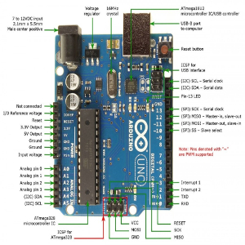
- Arduino uno datasheet R3 -

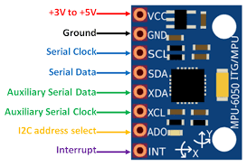
- Mpu6050 datasheet –

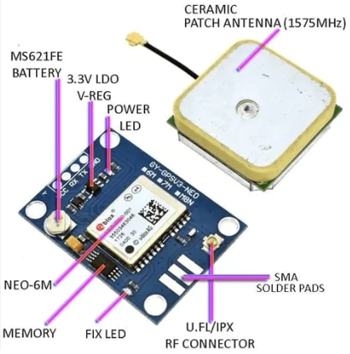
- Gps neo6m-
- Page-15-
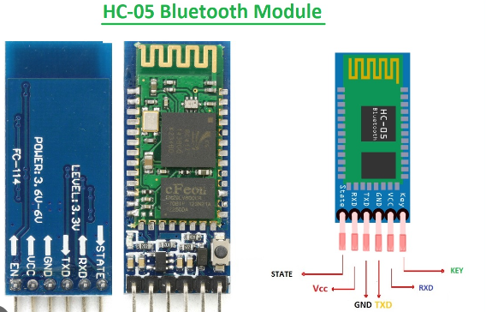
- Hc-05 bluetooth datasheet -
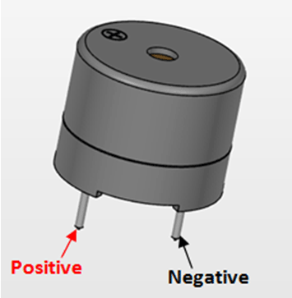
-buzzer datasheet-
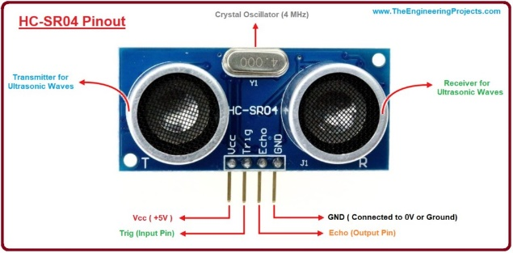
-Ultrasonic datasheet –
Page-16-

Bibliography:
https://learn.adafruit.com/
https://youtu.be/E84ROlwPnqM
https://lastminuteengineers.com/
https://invensense.tdk.com/wp-content/uploads/2015/02/MPU-6000-Datasheet1.pdf

page-17-

